VAT BOT

## Instructions

App version 2.0

Instructions for “VAT BOT”

**Please read and follow all the instructions for a proper use of application!**

## Prerequisites:

1. VAT Declaration (D300)
2. TB template – should be made on the template presented down below:



In the TB Template, map the information from the Trial Balance provided by the client, onto the Template shown here accordingly. (Account, Description, Opening Balance, Movement Debit & Credit and Closing Balance,)

|  |  |  |  |  |  |
| --- | --- | --- | --- | --- | --- |
| Account | Description | OB | DM | CM | CB |
| 401 | Vendors | 2.341 | 34.325 | 5.353 | 31.313 |

## Instructions:

1. Open the app:

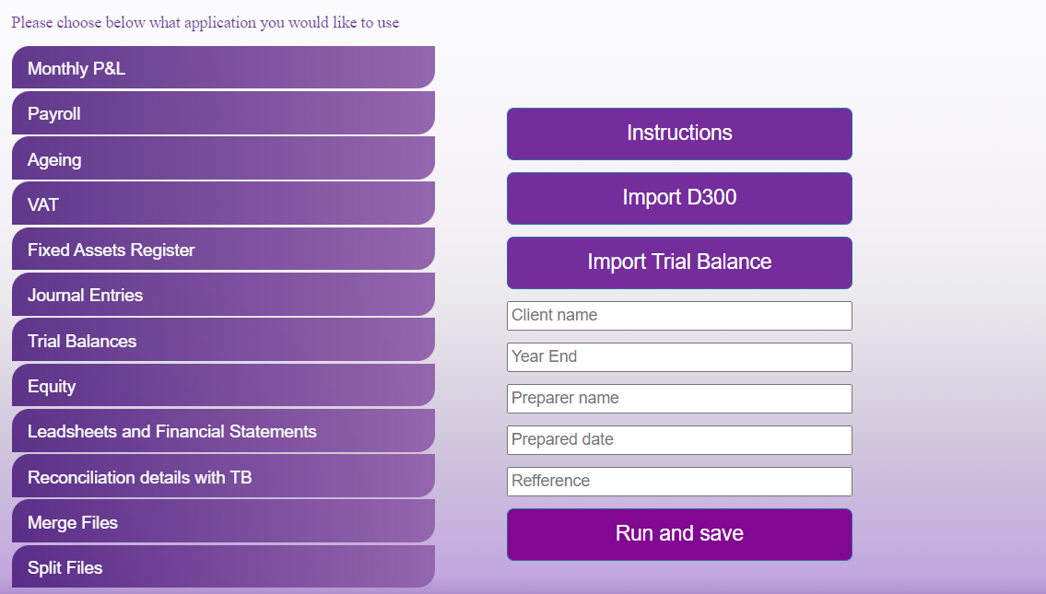

1. Click “Import D300” button and upload D300 declarations.
2. Click “Import Trial Balance” button and select the TB template.
3. In the “Client name”, “Year End”, “Preparer name” and “Prepared date” introduce the information accordingly.
4. Click “Run and save”. Once clicking that, the robot will process your request and exit the application.
5. Finally, you should obtain an Excel document named “VAT test + client name”

Note: Please do not modify any of the templates provided!

If you encounter any issues or if you have any other questions or suggestions, please contact:

Cristian Iordache, [cristian.iordache@ro.gt.com](mailto:cristian.iordache@ro.gt.com)

Bogdan Constantinescu, bogdanconstantinescu@ro.gt.com